# Jquery and js

## Methods

### .map and each

,map is totally equal to forEach.

We can use forEach in bellow instead of .map and $.each.

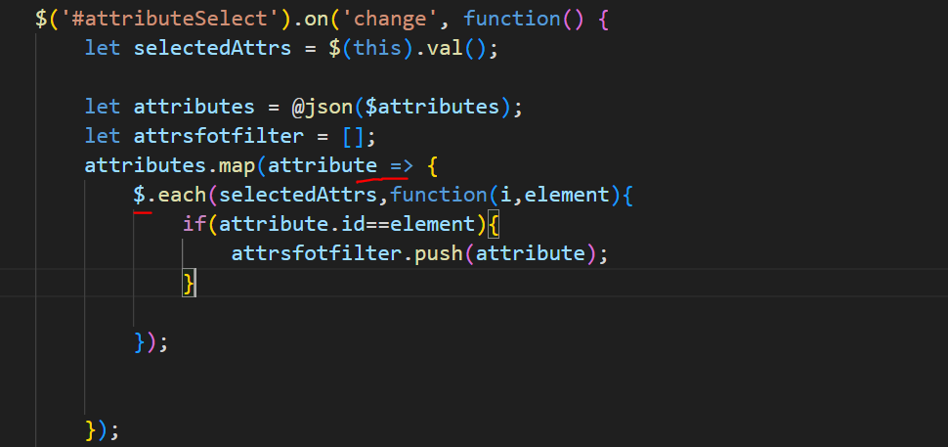

We cant use map for selectedAttrs because it is jquey element.

## Bulid tag with jquey

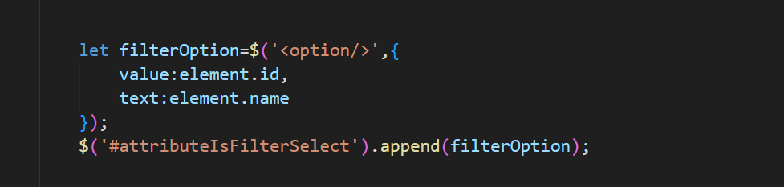

How to create nested tags

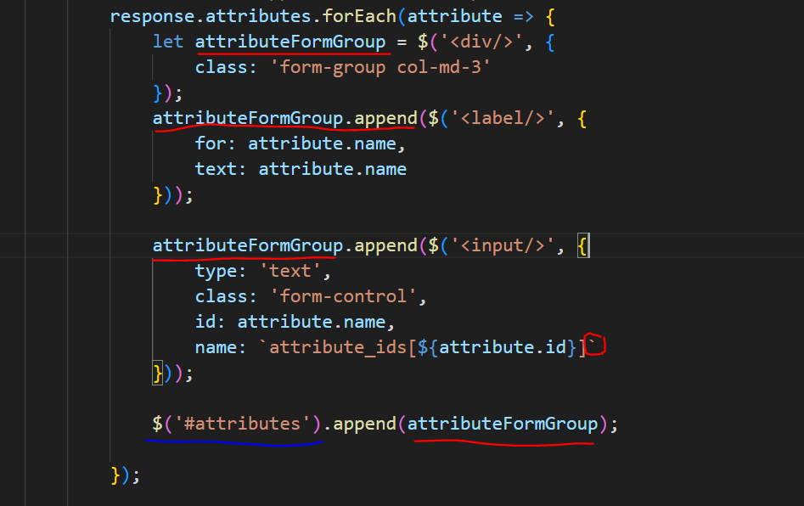

## Use data of php in jquery:

1-**blade directive**: we use this method when we want a variable in php back as a js object for interact on page with js we send data with method number 2.

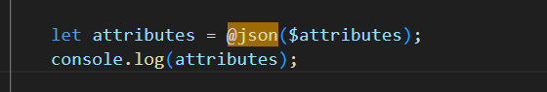

Above directive will create an object from php.

2- when we want to have amonts of php variables via interact with the page we should use an attribute to make a array with json encode(json is a common data carry articture in all languges) and in js we can use js function to make it a js object

-



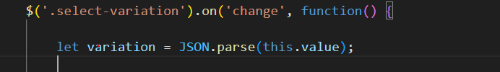

-in js picture<< this>> is an option element.

# file upload input:



we can use bootstrap with following steps.

Html:

 <div class="form-group col-md-3">

    <label for="primary_image"> انتخاب تصویر اصلی </label>

    <div class="custom-file">

     <input type="file" name="primary_image" class="custom-file-input" id="primary_image">

      <label class="custom-file-label" for="primary_image"> انتخاب فایل </label>

     </div>

 </div>

Extera css for proper apperiance in persion:

.custom-file-label::after {

    content: "فایل";

}

.custom-file-label:after {

    right: unset;

    left: 0;

    border-left: unset;

    border-right: inherit;

    border-radius: 0.35rem 0 0 0.35rem;

}

Jquery to set file name after choose a file:

// Show File Name

        $('#primary_image').change(function() {

            //get the file name

            var fileName = $(this).val();

            //replace the "Choose a file" label

            $(this).next('.custom-file-label').html(fileName);

        });

# Ajax

## Get:

let categoryId = $(this).val();

$.get(

`{{ url('/admin-panel/management/category-attributes/${categoryId}') }}`,

function(response,status) {

   if (status == 'success') {

console.log(response);

   } else {

    alert('مشکل در دریافت لیست ویژگی ها');

   }

 }).fail(function() {

                alert('مشکل در دریافت لیست ویژگی ها');

 })

## Post:

        $.post("{{ url('resend-otp') }}", {

            '_token': "{{ csrf_token() }}",

            'login_token': loginToken,

        }, function(response, status) {

            console.log(response, status);

        }).fail(function(response) {

            console.log('fff', response, 'ggg');

        });

# Packages and functions

Tip you beter first work with cdn after like the package then add its files.

## Chart:

<https://www.chartjs.org/>

Amcharts.com

## Having a map

<https://leafletjs.com/>

I only worked with this and I think it is enough for me.

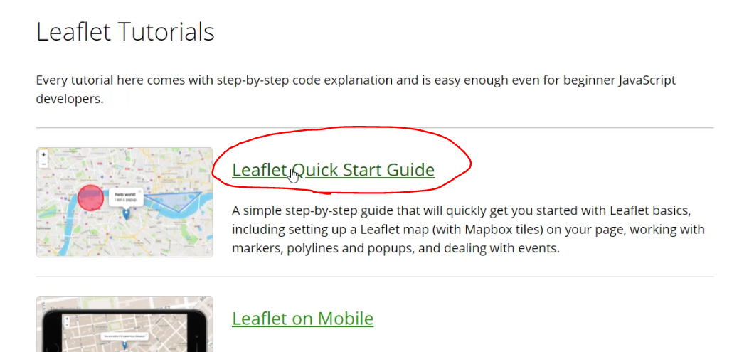

## Sweet-alert:

<https://github.com/realrashid/sweet-alert>

on js:

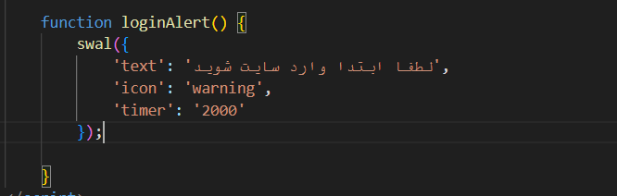

## Data time picker shamsi:

<https://github.com/Mds92/MD.BootstrapPersianDateTimePicker>

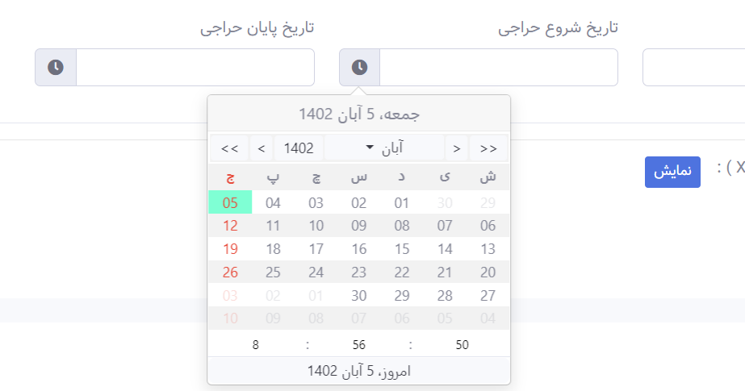

Input sorce code:

<div class="form-group col-md-3">

<label> تاریخ شروع حراجی </label>

<div class="input-group">

<div class="input-group-prepend order-2">

<span class="input-group-text" id="variationDateOnSaleFrom-{{ $variation->id }}">

<i class="fas fa-clock"></i>

</span>

</div>

<input type="text" class="form-control" id="variationInputDateOnSaleFrom-{{ $variation->id }}"

name="variation_values[{{ $variation->id }}][date_on_sale_from]"

value="{{ $variation->date_on_sale_from == null ? null : verta($variation->date_on_sale_from) }}">

</div>

</div>

Js base on bootstrap 4 and jquery:

  $(`#variationDateOnSaleFrom-${variation.id}`).MdPersianDateTimePicker({

                targetTextSelector: `#variationInputDateOnSaleFrom-${variation.id}`,

                englishNumber: true,

                enableTimePicker: true,

                textFormat: 'yyyy-MM-dd HH:mm:ss',

            });

in episod 68 of laravel project its toutorial of datepicker on bootstrap4 but I rather to work with the new one.

## CzMore:

<https://github.com/cozeit/czMore>

notes: we have to change the image path in czmore library based on our server public directory

or we can delete image part and append a <i/> tag with fa-plus class and …

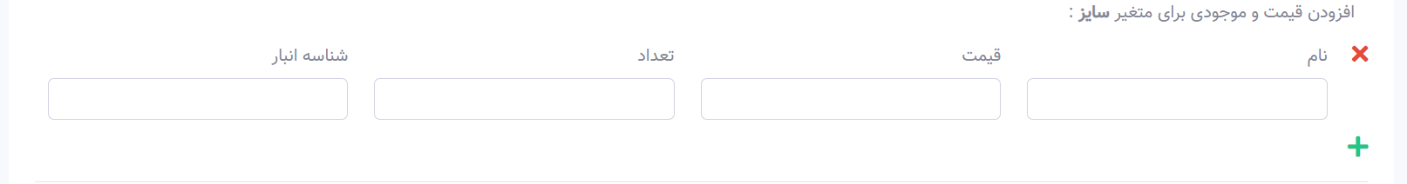product create.blade(episod 50)

## Select picker

Packege name: bootsrap-select

This have a command to refresh selectpicker for the times when we make an option tag after loading the page:



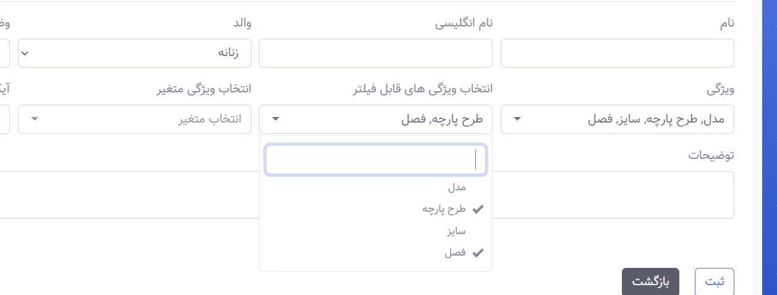

<https://developer.snapappointments.com/bootstrap-select/>

## star icons:

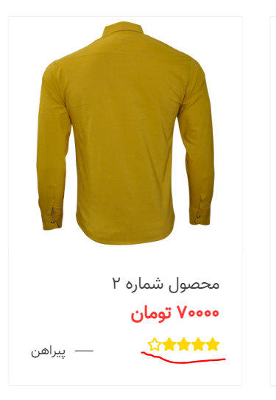

<https://www.jqueryscript.net/other/rating-star-icons.html>

episod 98

## timer():

  function timer() {

            //  alert('timer');

            let time = "0:10";

            let interval = setInterval(function() {

                let countdown = time.split(':');

                let minutes = parseInt(countdown[0], 10);

                let seconds = parseInt(countdown[1], 10);

                --seconds;

                minutes = (seconds < 0) ? --minutes : minutes;

                if (minutes < 0) {

                    clearInterval(interval);

                    $('#timer-btn').attr('id', 'resendBtn');

                    $('#resendBtn').text('ارسال مجدد');

                    $('#resendBtn').removeClass('disabled');

                    $('#resendBtn').click(function() {

                        if ($(this).attr('id') == 'resendBtn') {

                            resend(loginToken);

                        }

                    });

                };

                seconds = (seconds < 0) ? 59 : seconds;

                seconds = (seconds < 10) ? '0' + seconds : seconds;

                //minutes = (minutes < 10) ?  minutes : minutes;

                $('#timer-btn').html(minutes + ':' + seconds);

                time = minutes + ':' + seconds;

            }, 1000);

        }

# Preloader

Note:bellow is just a sample just search preloader sample in google.

Html:

        <div class="text-center">

            <div id="overlayer"></div>

            <span class="loader">

                <span class="loader-inner"></span>

            </span>

        </div>

Css:

#overlayer {

    width: 100%;

    height: 100%;

    position: fixed;

    z-index: 10000;

    background: #4a4a4a;

}

.loader {

    display: inline-block;

    width: 30px;

    height: 30px;

    position: fixed;

    z-index: 20000;

    border: 4px solid #fff;

    top: 50%;

    -webkit-animation: loader 2s infinite ease;

    animation: loader 2s infinite ease;

}

.loader-inner {

    vertical-align: top;

    display: inline-block;

    width: 100%;

    background-color: #ac8888;

    -webkit-animation: loader-inner 2s infinite ease-in;

    animation: loader-inner 2s infinite ease-in;

}

@-webkit-keyframes loader {

    0% {

        transform: rotate(0deg);

    }

    25% {

        transform: rotate(180deg);

    }

    50% {

        transform: rotate(180deg);

    }

    75% {

        transform: rotate(360deg);

    }

    100% {

        transform: rotate(360deg);

    }

}

@keyframes loader {

    0% {

        transform: rotate(0deg);

    }

    25% {

        transform: rotate(180deg);

    }

    50% {

        transform: rotate(180deg);

    }

    75% {

        transform: rotate(360deg);

    }

    100% {

        transform: rotate(360deg);

    }

}

@-webkit-keyframes loader-inner {

    0% {

        height: 0%;

    }

    25% {

        height: 0%;

    }

    50% {

        height: 100%;

    }

    75% {

        height: 100%;

    }

    100% {

        height: 0%;

    }

}

@keyframes loader-inner {

    0% {

        height: 0%;

    }

    25% {

        height: 0%;

    }

    50% {

        height: 100%;

    }

    75% {

        height: 100%;

    }

    100% {

        height: 0%;

    }

}

Jquery:

 $(window).load(function() {

            $(".loader").fadeOut("slow");

            $("#overlayer").fadeOut("slow");

        })